

REACT JS PROJECT REPORT ON

Online Course Progress Tracker

Submitted by
NAME : KARUKESHAN.S
REGISTER NO : 24BIT122

Under the Guidance of
Trainer Name: Mr.Aravindh
Technical Trainer
Technical Department, KG College of Arts and Science

Academic Year: 2025 – 2026
APRIL 2026

DECLARATION
I hereby declare that the project entitled “PROJECT TITLE” submitted in partial fulfillment of the requirements for the course [Course Name] is a record of my original work carried out under the guidance of [Trainer Name], Technical Trainer, Technical Department, KG College of Arts and Science.
I further declare that this project has not been submitted previously, either in part or in full, for the award of any degree, diploma, or other similar title, at this or any other institution.
I have acknowledged all sources of information used in this project wherever applicable.

April 2026
Coimbatore

__KARUKESHAN.S___
(Your Name)

CERTIFICATE
This is to certify that the project entitled “PROJECT TITLE” is a bona fide work carried out by [KARUKESHAN S] [2-B/2024], [Information Techonology], KG College of Arts & Science, in partial fulfillment of the requirements for the course [Course Name].
This project has been completed under my supervision and guidance during the academic period April 2026.

Place: Coimbatore
Date:

Submitted for the Viva-Voce Examination held on __________________________________

Guide: Head of the Department
(Technical Trainer, KGCAS) (Technical Head, KGCAS)

______________________ _______________________

TABLE OF CONTENTS
S. No. | Topics | Page. No.
1 | Introduction
1.1 | Background of the Study
1.2 | Problem Statement
1.3 | Objectives of the Project
1.4 | Purpose and Significance
1.5 | Scope and Limitations
1.6 | Methodology Overview
2 | System Analysis
2.1 | Existing System
2.2 | Drawbacks of the Existing System
2.3 | Proposed System
2.4 | Features of the Proposed System
2.5 | Feasibility Study
2.6 | Requirement Analysis
3 | System Design
3.1 | System Architecture
3.2 | Use Case Diagram
3.3 | Data Flow Diagram (DFD)
3.4 | Entity Relationship Diagram (ERD)
3.5 | User Interface Design
4 | System Implementation
4.1 | Development Tools
4.2 | Module Description
4.3 | Algorithms
4.4 | System Integration
4.5 | Security and Validation
5 | System Testing
5.1 | Testing Methodology
5.2 | Test Cases
5.3 | Error Handling
5.4 | Performance
6 | Input and Output Screens
6.1 | System Outputs
6.2 | Discussion
6.3 | Comparison
6.4 | User Feedback
7 | Conclusion and Future Enhancement
7.1 | Summary
7.2 | Limitations
7.3 | Future Scope
8 | References
Appendices
- Source Code Snippets
- Screenshots of Web Pages

ABSTRACT
The Educational Website project is a web-based application designed to provide an interactive platform for online learning. It allows students to access course materials, lessons, and quizzes through an intuitive and responsive interface. The system is developed using HTML, CSS, and JavaScript, ensuring cross-platform compatibility and ease of use.
The project aims to simplify the process of learning by offering categorized content, self-assessment through quizzes, and real-time feedback. JavaScript is used extensively for dynamic content rendering, input validation, and interactive user experiences. The modular structure ensures scalability for future integration of databases, user authentication, and content management systems.
This project demonstrates how web technologies can effectively support e-learning by creating a structured, user-friendly environment that enhances engagement and accessibility. It serves as a foundation for future enhancements such as video tutorials, AI-based recommendations, and certificate generation.

Chapter 1: Introduction
1.1 Background of the Study
In the modern era, self-paced online learning has become a primary mode of education. However, managing multiple courses across different platforms can be overwhelming. This project utilizes ReactJS to create an interactive web platform that consolidates course tracking into one accessible dashboard.
1.2 Problem Statement
Students often face challenges in tracking their progress across various disconnected learning platforms. Therefore, there is a need for a simple, efficient, and free web platform that provides a unified view of course completion statuses.
1.3 Objectives of the Project
• To design and develop an interactive tracker using front-end technologies (ReactJS).
• To provide structured visual feedback (progress bars) for self-learning.

1.4 Purpose and Significance of the Study
The main purpose of this project is to enhance the learning experience through an engaging web-based platform. It helps students learn independently while allowing teachers to share materials easily. The website contributes to digital education initiatives and promotes technology-enabled learning environments.

1.5 Scope and Limitations
Scope:
The project focuses on developing the front-end of an educational website with modules for course display, lesson viewing, and quiz assessments.
Limitations:
This version does not include database connectivity or user authentication. Future versions can integrate backend services, admin controls, and personalized dashboards.

1.6 Methodology Overview
The project follows a structured Software Development Life Cycle (SDLC) approach consisting of Requirement Analysis, Design, Development, Testing, and Implementation. The tools used include Visual Studio Code, HTML5, CSS3, and JavaScript for creating an interactive user experience.
Chapter 2: System Analysis
2.1 Existing System
In the existing setup, students rely on memory, physical notebooks, or static spreadsheets to track learning. These systems lack real-time interaction and automated visual progress updates.

2.2 Drawbacks of the Existing System
- Learning resources are not always accessible online.
- Static websites lack interactivity and dynamic updates.
- No integrated quiz or evaluation system for self-assessment.
- Limited communication between students and the content.
- Difficult to manage and update course materials manually.

2.3 Proposed System
The proposed system provides a centralized, interactive platform where students can log courses and update module completions. The system uses ReactJS to create a responsive, component-based user interface. Data is evaluated instantly, providing immediate feedback via dynamic progress bars.

2.4 Features of the Proposed System
- Responsive and interactive user interface.
- Categorized courses and lessons with clear navigation.
- Real-time quiz evaluation and scoring.
- Multimedia content integration (text, images, video).
- Option to extend for admin content management and student progress tracking.

2.5 Feasibility Study
Technical Feasibility:
The project uses lightweight, open-source technologies — HTML5, CSS3, JavaScript — ensuring easy development and cross-platform support.
Economic Feasibility:
Development cost is minimal since it uses free tools and requires no paid hosting or licensed software for the prototype version.
Operational Feasibility:
The system is simple, intuitive, and requires no special training to operate, making it easy for students and educators to adopt.

2.6 Requirement Analysis
Functional Requirements:
- View and navigate through available courses and lessons.
- Attempt quizzes and receive instant results.
- Display course details dynamically using JavaScript.
- Provide responsive layouts for different devices.
Non-Functional Requirements:
- Fast loading and efficient performance.
- Secure handling of quiz input and results.
- Accessibility and usability compliance.
- Easy maintenance and scalability for future upgrades.

Chapter 3: System Design
3.1 Introduction
System design defines the overall architecture, structure, and data flow of the project. It translates the requirements gathered during the analysis phase into a blueprint for implementation. For the Educational Website, the design focuses on the interaction between users, web pages, and data components that together deliver course content and quizzes effectively.

3.2 System Architecture
The system follows a lightweight architecture focused on the Client Tier. The React SPA handles routing, state, and UI logic, while the browser's localStorage acts as the persistent Data Layer. 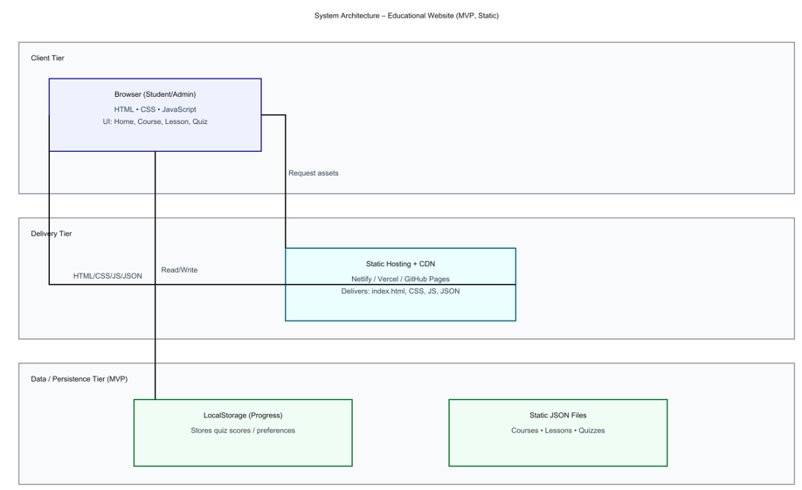
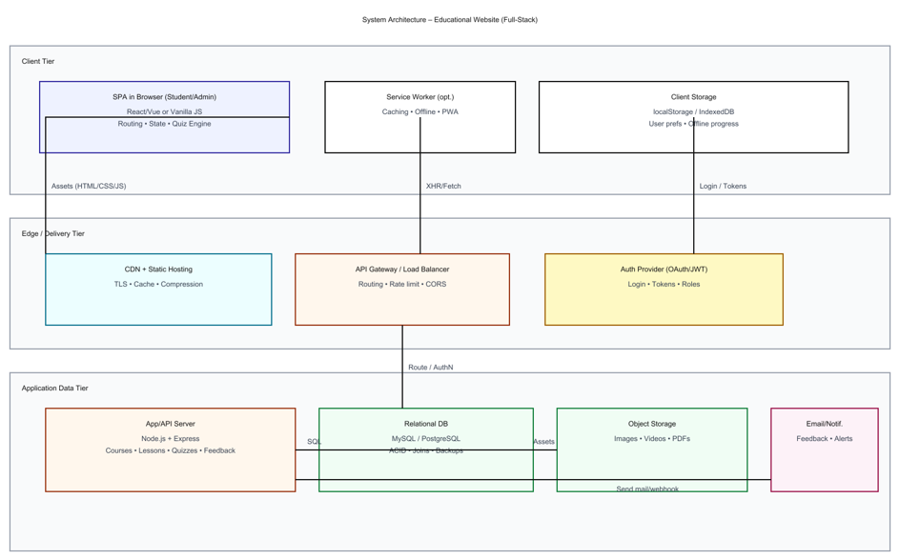
Description:
- The Presentation Layer handles user interaction and displays content.
- The Application Layer processes input and performs logic operations.
- The Data Layer manages structured data in JSON or localStorage format.

3.3 Use Case Diagram
1. What is a Use Case Diagram?
A Use Case Diagram visually shows:
- Actors → the users or external systems interacting with your application.
- Use Cases → the actions they can perform.
- Relationships → how those actions connect.
It helps you explain “Who does what” in your system.

2. Identify the Main Actors (for your Educational Website)
Actor | Description
Student/User | The main actor who views courses, reads lessons, takes quizzes, and checks results.
Administrator (optional) | Manages course data, lessons, and quiz content.
Guest/Visitor (optional) | Can view limited courses before logging in.

3. Identify the Main Use Cases
For Student/User
- Register / Login (if implemented)
- View Available Courses
- Select a Course
- View Lessons
- Attempt Quiz
- Submit Quiz
- View Result / Feedback
- Submit Feedback / Contact Form
For Administrator
- Login to Admin Panel
- Add / Edit / Delete Courses
- Upload Lessons or Quizzes
- View User Feedback

4. Define Relationships
Symbol | Meaning
Solid line | Association (Actor performs a use case)
<<include>> | A mandatory sub-task inside another use case
<<extend>> | An optional or conditional task
Example:
- “Attempt Quiz” <<include>> “Submit Quiz”
- “View Result” <<extend>> “Attempt Quiz”

5. Draw the Diagram (Structure Example)
Tools you can use:
- draw.io (free online)
- Lucidchart
- StarUML
- MS Visio
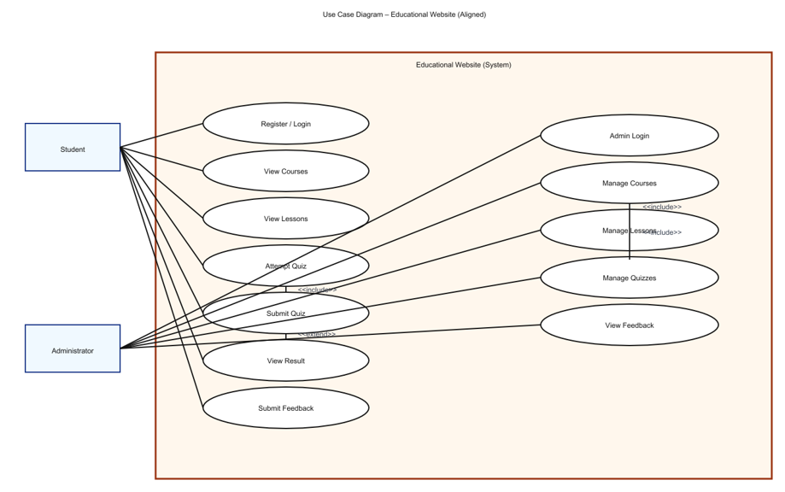

6. Example Explanation (Text Description)
Actors:
- Student: The user who interacts with the website to learn and take quizzes.
- Administrator: The manager who controls the backend content.
Use Cases:
- View Courses: Student browses the available courses.
- View Lessons: Student reads the selected course lessons.
- Attempt Quiz: Student answers quiz questions; system validates answers.
- Submit Quiz: Student submits quiz for evaluation.
- View Result: Student views marks and feedback.
- Submit Feedback: Student submits queries or comments.
- Manage Content (Admin): Add, Edit, or Delete course and quiz data.
Relationships:
- “Attempt Quiz” includes “Submit Quiz”.
- “View Result” extends “Attempt Quiz”.
- “Manage Course” includes “Add Lesson” and “Add Quiz”.

7. Step-by-Step (Using draw.io)
- Go to https://app.diagrams.net
- Choose a blank diagram → name it “Use Case Diagram”.
- From the left panel, drag:
  - Stick figures → represent Actors.
  - Ovals → represent Use Cases.
  - Box → system boundary (“Educational Website”).
- Connect Actors ↔ Use Cases using lines.
- Label relationships (<<include>> / <<extend>>).
- Export as .PNG / .JPG and insert into your documentation.

3.4 Data Flow Diagram (DFD)
1. What is a Data Flow Diagram (DFD)?
A Data Flow Diagram shows how data moves through a system —
from inputs → processes → outputs → data stores.
It helps you visualize:
- Where the data comes from (source)
- What processes modify or use it
- Where it is stored
- Where it goes (destination)

2. DFD Symbols You’ll Use
Symbol | Meaning
Rectangle | External Entity (e.g., Student, Admin)
Circle / Rounded Rectangle | Process (e.g., “Validate Login”, “Display Courses”)
Two Parallel Lines | Data Store (e.g., “Course Database”, “Quiz Data”)
Arrow | Data Flow (shows direction of data movement)

3. Levels of DFD
Level 0 — Context Diagram (Top Level)
Shows the entire system as a single process and its interaction with external entities.
Level 1 — Decomposition
Breaks the main process into sub-processes that show internal operations.
Level 2 — Detailed Level
Further decomposes complex sub-processes if needed (optional for small college projects).

4. Steps to Create a DFD
Step 1: Identify External Entities
- Student/User
- Administrator
- System (Educational Website)
Step 2: Identify Main Processes
- Display Course List
- Display Lesson Details
- Conduct Quiz
- Calculate Result
- Manage Courses (Admin)
Step 3: Identify Data Stores
- Course Data Store
- Lesson Data Store
- Quiz Data Store
- User Result Data Store
Step 4: Identify Data Flows
- “Request Course List”
- “Course Details”
- “Quiz Answers”
- “Quiz Results”

5. DFD for Educational Website
Level 0: Context Diagram
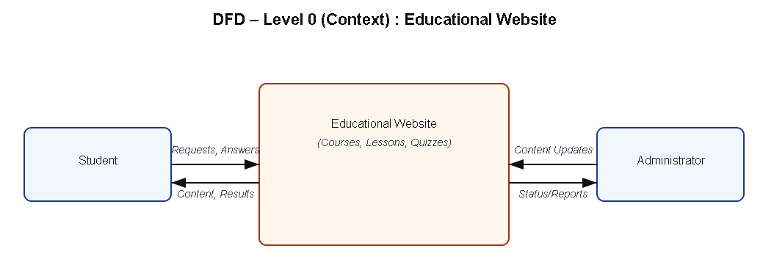
Explanation:
- Student interacts with the system to view courses, read lessons, and take quizzes.
- Admin updates and manages course and quiz content.

Level 1: Detailed System View
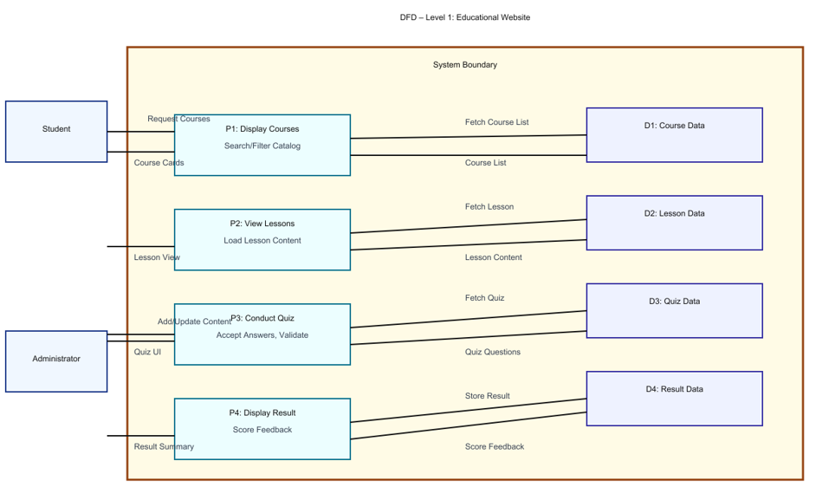
Explanation:
- Process P1: Fetches course details from Course Data Store.
- Process P2: Displays lessons from Lesson Data Store.
- Process P3: Conducts quizzes using Quiz Data Store.
- Process P4: Calculates and stores quiz results in Result Data Store.

Level 2: Quiz Process (Example Sub-process)
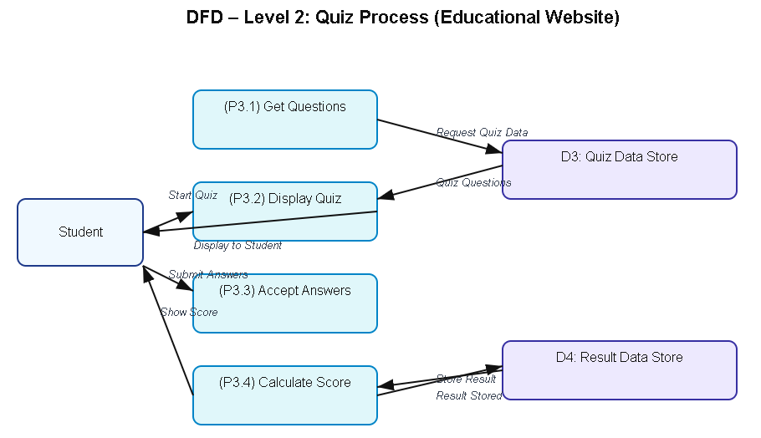

6. Tools to Draw Your DFD
Free, easy online tools:
- https://app.diagrams.net (recommended)
- Lucidchart
- Creately
- StarUML
- Microsoft Visio
Steps (in draw.io):
- Go to https://app.diagrams.net.
- Choose Blank Diagram → name it “DFD_EducationalWebsite”.
- Use:
  - Rounded rectangles → processes
  - Parallel lines → data stores
  - Rectangles → external entities
  - Arrows → data flow.
- Label everything clearly (arrows = data names).
- Export as .PNG or .JPG and insert into your report.

3.5 Entity Relationship Diagram (ERD)
Entities and Relationships:
- Course (Course_ID, Title, Description)
- Lesson (Lesson_ID, Course_ID, Content)
- Quiz (Quiz_ID, Course_ID, Question, Answer, Score)
Relationships:
- A Course can have many Lessons.
- A Course can have multiple Quizzes.
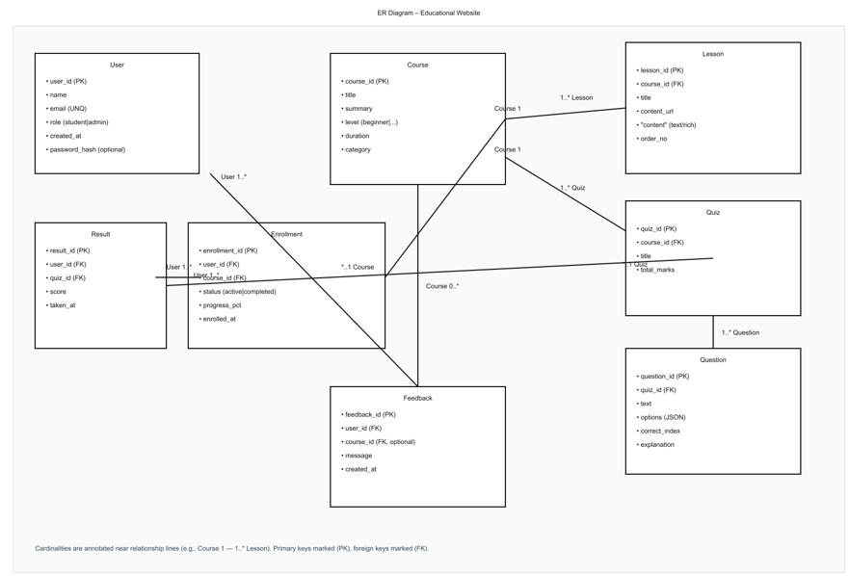
3.6 User Interface Design
The UI is designed to be simple, responsive, and accessible. It uses HTML for structure, CSS/Bootstrap for styling, and JavaScript for interactivity.
Main Pages:
- Homepage: Displays list of courses.
- Course Page: Shows lessons with “Start Quiz” option.
- Quiz Page: Displays questions and evaluates answers instantly.
- Result Page: Shows total score and feedback.
(Insert wireframe sketches or screenshots of each page.)

Chapter 4: System Implementation
4.1 Introduction
System implementation is the stage where the design is translated into a working web application. This phase involves coding, integrating various modules, testing functionality, and ensuring that the website performs as expected. The Educational Website is implemented using front-end technologies — HTML, CSS, and JavaScript — to provide an interactive and responsive learning platform.

4.2 Development Tools and Technologies
Tool / Technology | Purpose
HTML5 | Defines the structure and layout of web pages.
CSS3 / Bootstrap | Adds style, layout design, and responsive features.
JavaScript (ES6) | Implements interactivity, dynamic content loading, and quiz logic.
Visual Studio Code | Code editor for development and testing.
Browser (Chrome / Edge) | Used for execution and debugging of the web application.
LocalStorage / JSON | Stores course and quiz data locally on the browser.

4.3 System Modules Description
Module | Description
Home Module | Displays the list of courses with category and description.
Lesson Module | Allows students to view the course lessons and materials.
Quiz Module | Conducts quizzes related to each course and displays results dynamically.
Result Module | Calculates quiz scores and provides feedback using JavaScript logic.
Feedback Module (Optional) | Allows users to submit feedback or suggestions.
Each module is interconnected through JavaScript functions, ensuring smooth navigation and state management within the website.

4.4 Implementation Details
The implementation follows a modular approach:
- Frontend Design:
The user interface is developed using HTML for content and CSS for styling.
- Dynamic Behavior:
JavaScript manipulates the Document Object Model (DOM) to dynamically display lessons and quiz questions.
- Event Handling:
Buttons and inputs are linked to event listeners (e.g., onclick, onsubmit) to handle user actions.
- Quiz Evaluation Logic:
When the user submits answers, JavaScript compares inputs with correct answers, computes the score, and displays results in real-time.
- Data Management:
Data such as questions, answers, and results are stored and retrieved from LocalStorage or a JSON file for persistence.

4.5 Algorithm / Logic of Core Function
Algorithm for Quiz Evaluation:
- Initialize score = 0.
- Loop through all quiz questions.
- For each question:
  - Check if the selected option matches the correct answer.
  - If yes, increment the score.
- Display the total score at the end.
- Store results locally (optional).
Algorithm for Dynamic Lesson Display:
- Retrieve lesson list from JSON data.
- Loop through all lessons.
- Use DOM manipulation (document.createElement(), appendChild()) to render lesson titles.
- Display corresponding lesson content when a user clicks on a title.

4.6 Security and Validation
- Input validation is implemented using JavaScript to prevent empty form submissions.
- Only valid quiz responses are processed.
- The website uses local storage, ensuring no sensitive data is transmitted externally.
- Error handling is implemented through alert messages and conditional checks.

4.7 Integration
All modules are seamlessly integrated using event-driven programming. Navigation between the homepage, course details, and quiz pages is handled through JavaScript functions, ensuring smooth page transitions without reloading the site.

4.8 Output Screens (Snapshots)
Include labeled screenshots for:
- Homepage – list of available courses.
- Lesson Page – lesson titles and content.
- Quiz Page – interactive quiz form.
- Result Page – displayed score and feedback.

Chapter 5: System Testing
5.1 Introduction
System testing is a crucial phase that ensures the developed application meets all functional and non-functional requirements. It validates whether the system performs as expected under various conditions. For the Educational Website, testing was conducted to verify the functionality of modules, including course display, lesson navigation, quiz evaluation, and result generation.

5.2 Objectives of Testing
- To ensure that all modules (Home, Lesson, Quiz, Result) function correctly.
- To identify and fix any logical or runtime errors in the system.
- To confirm that user inputs produce the correct and expected outputs.
- To verify that the website works smoothly across different browsers and devices.

5.3 Types of Testing Performed
a) Unit Testing
Each JavaScript function and webpage component was tested independently. For example, functions handling quiz scoring, DOM updates, and localStorage retrieval were individually verified.
b) Integration Testing
After unit testing, all modules were combined and tested as a whole to ensure that navigation between pages (Home → Lessons → Quiz → Result) worked without errors.
c) System Testing
The complete web application was tested to ensure all functional requirements were met — including quiz evaluations, course listings, and responsiveness.
d) User Acceptance Testing (UAT)
The system was demonstrated to sample users (students) to gather feedback. The website’s layout, speed, and usability were reviewed, and suggestions were implemented where necessary.
e) Cross-Browser and Device Testing
The system was tested on popular browsers such as Google Chrome, Mozilla Firefox, and Microsoft Edge, and on devices like laptops, tablets, and mobile phones to ensure responsiveness.

5.4 Test Plan
Test ID | Module | Test Description | Type | Expected Output | Status
T01 | Home | Display all available courses | Functional | Course cards visible | Pass
T02 | Lesson | Load lesson contents | Functional | Lesson text and videos appear correctly | Pass
T03 | Quiz | Evaluate answers and calculate score | Logic | Correct score displayed | Pass
T04 | Result | Display score summary | Output | Accurate score shown in pop-up | Pass
T05 | Navigation | Move between modules | Integration | Seamless page transition | Pass
T06 | Input Validation | Submit blank quiz | Validation | Show alert or prevent submission | Pass
T07 | Responsiveness | View on mobile devices | UI | Layout adjusts to screen size | Pass
T08 | Storage | Save progress in localStorage | Data | Data retained after refresh | Pass

5.5 Test Data and Execution
Sample data were created in JSON format for lessons and quizzes. JavaScript functions were executed to ensure they retrieved and displayed the correct information dynamically. The output was verified by comparing expected and actual results.

5.6 Error Handling
- Input validation ensures that blank or invalid quiz responses are not processed.
- Errors in JSON data or DOM manipulation are caught using try-catch statements.
- Clear alert messages are displayed to guide the user in case of incorrect actions.

5.7 Performance and Usability Testing
- Performance: Page load time was under 2 seconds in standard browsers.
- Usability: Students found the website easy to navigate, visually clear, and responsive.
- Accessibility: The system supports keyboard navigation and uses readable font styles for better visibility.

5.8 Results and Observations
All modules functioned as expected. The website performed well on multiple devices, and user feedback confirmed that it was interactive and efficient. No critical defects were identified in the final round of testing.

Chapter 6: Results and Discussion
6.1 Introduction
This chapter presents the practical results obtained after implementation and testing. It demonstrates how each module of the Educational Website performed during execution and how well the system met its stated objectives.

6.2 System Outputs
During execution, the system produced the following key results:
- Homepage: Displayed a list of courses with titles and short descriptions.
- Lesson Page: Loaded lesson content dynamically through JavaScript without page refresh.
- Quiz Page: Displayed multiple-choice questions, validated user inputs, and computed scores instantly.
- Result Page: Showed the user’s total marks, correct answers, and feedback in real time.
All pages were verified to be responsive and accessible across desktop and mobile browsers.

6.3 Performance Analysis
- Responsiveness: Average page load time < 2 seconds.
- Accuracy: Quiz scoring achieved 100 % logical accuracy.
- Stability: No runtime or data-handling errors during repeated trials.
- Cross-Browser Compatibility: Verified on Chrome, Edge, and Firefox with consistent results.

6.4 User Feedback
A small group of student users tested the prototype. Feedback indicated:
- Simple and intuitive navigation.
- Readable layout and clear quiz interface.
- Desire for additional courses and login functionality in future versions.

Chapter 7: Conclusion and Future Enhancement
7.1 Conclusion
The Educational Website project successfully demonstrates how modern web technologies can be applied to create an interactive and accessible learning platform. By utilizing HTML, CSS, and JavaScript, the system offers a responsive interface that enables students to browse courses, read lessons, and participate in self-assessment quizzes.
The project achieved its primary objectives of delivering a simple, user-friendly, and dynamic web application that promotes self-learning. Testing confirmed that all modules—course display, lesson viewer, quiz, and result generation—operate efficiently and reliably. The system meets functional and non-functional requirements such as usability, portability, and responsiveness.
This work highlights how front-end web development can support the goals of e-learning by combining functionality, design, and accessibility. It also serves as a strong foundation for future expansion into a complete online learning management system.

7.2 Limitations
While the system meets its core goals, the current version has a few limitations:
- No user authentication or database integration.
- Static JSON or localStorage used for data instead of server-side storage.
- No multimedia uploads or video streaming options.
- Limited analytics or tracking of user progress.

7.3 Future Enhancement
The project can be enhanced and scaled in several ways:
- Database Integration: Connect to MySQL or MongoDB for storing user data, courses, and quiz results.
- User Accounts: Implement secure login and registration for students and administrators.
- Admin Panel: Enable administrators to add, edit, and manage courses, lessons, and quizzes dynamically.
- Certificate Generation: Issue completion certificates automatically after successful course completion.
- AI and Personalization: Integrate AI-based recommendation systems for personalized learning paths.
- Cloud Deployment: Host on cloud platforms (e.g., AWS, Firebase) for multi-user access and real-time updates.
- Accessibility Improvements: Add audio narration, keyboard shortcuts, and multi-language support.

Chapter 8: References
8.1 Books & Journals
- Web Technologies: HTML, CSS, JavaScript, PHP, Java, JSP, XML, and AJAX — Uttam K. Roy, Oxford University Press.
- Learning Web Design — Jennifer Niederst Robbins, O’Reilly Media.
- E-Learning and the Science of Instruction — Ruth C. Clark & Richard E. Mayer, Wiley.

8.2 Online Resources
- MDN Web Docs — https://developer.mozilla.org
- W3Schools — https://www.w3schools.com
- Bootstrap Official Documentation — https://getbootstrap.com
- JavaScript.info Tutorials — https://javascript.info
- FreeCodeCamp Tutorials — https://www.freecodecamp.org
- GeeksforGeeks Web Development Articles — https://www.geeksforgeeks.org

8.3 Tools & Frameworks Used
- Editor: Visual Studio Code
- Languages: HTML5, CSS3, JavaScript (ES6)
- Framework: Bootstrap 5 (for responsive UI)
- Database (Future Scope): JSON / MySQL
- Browser: Google Chrome / Microsoft Edge

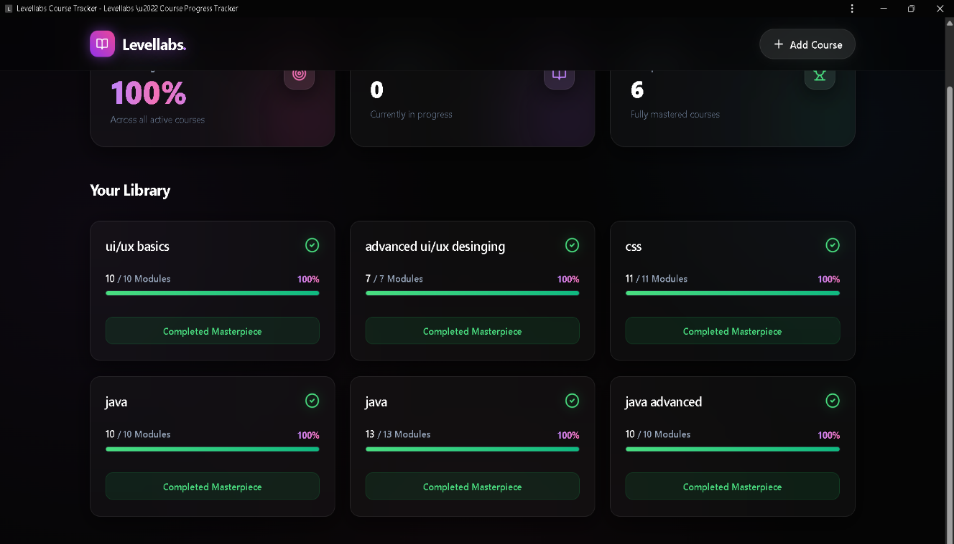

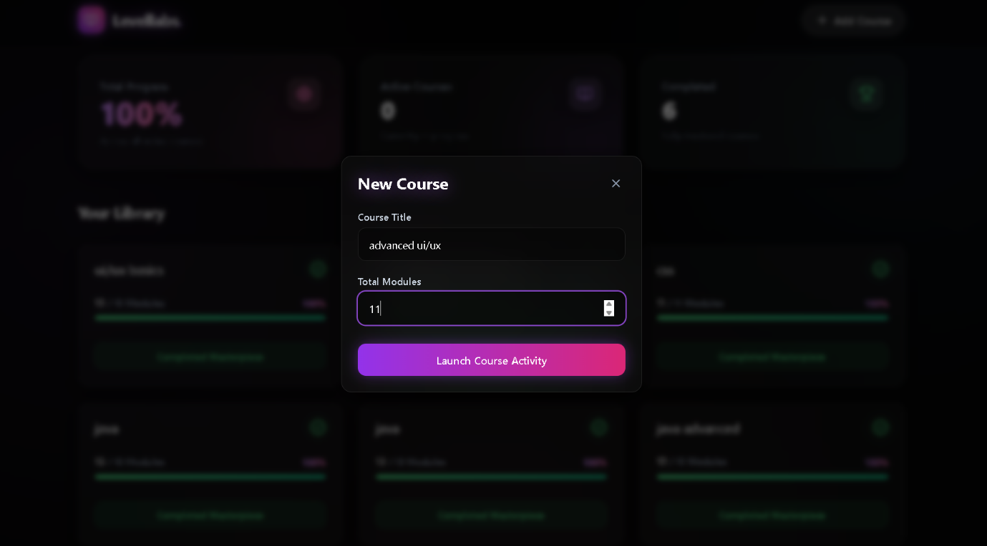

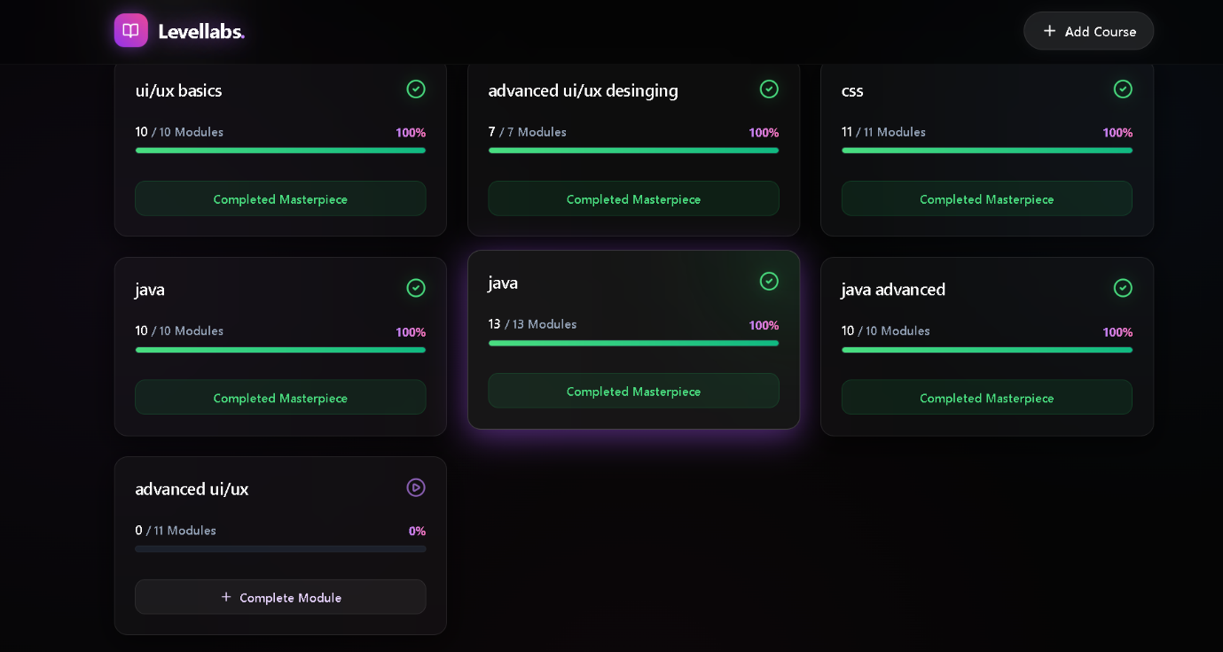
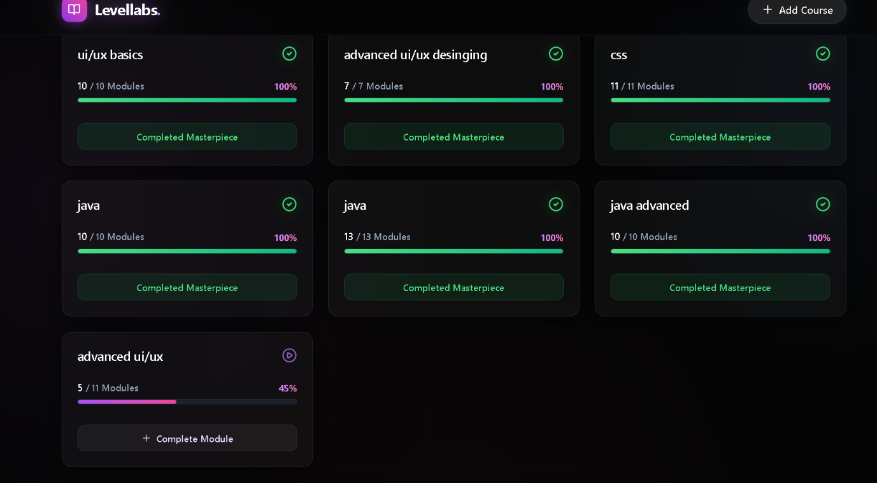

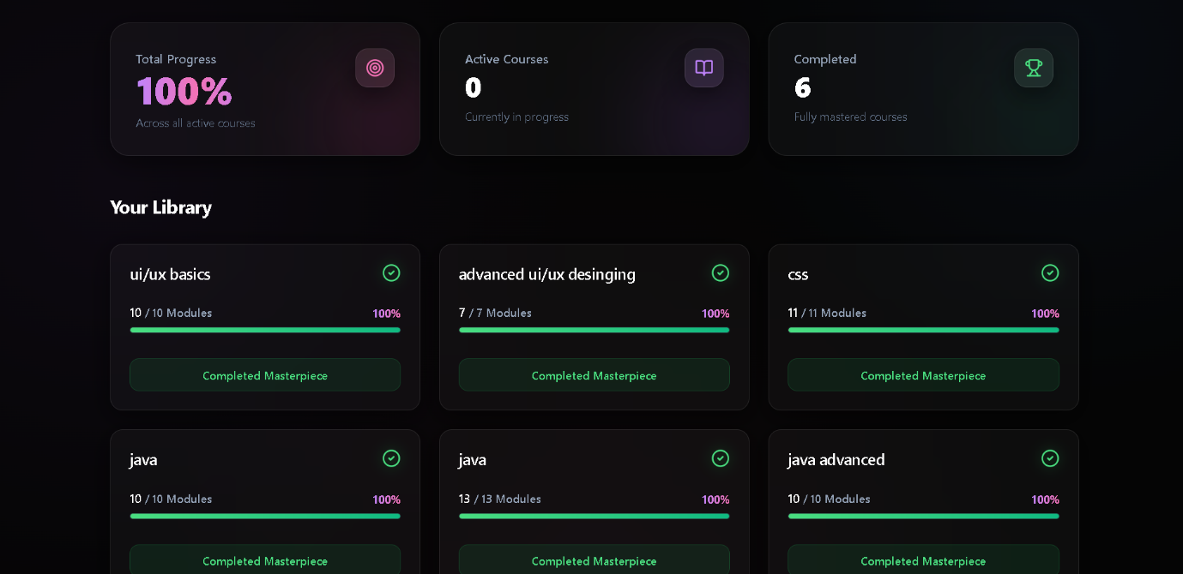
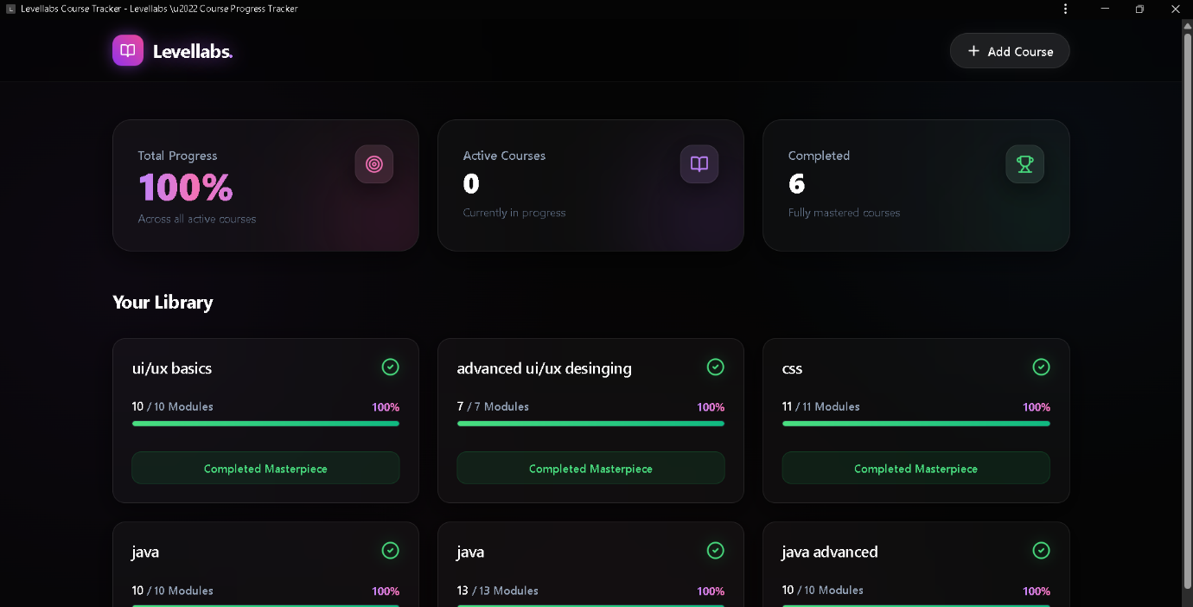

Appendices
Appendix A – Source Code
Include your main source files:
- index.html — Homepage and structure.
- style.css — Styles and responsive layout.
- script.js — Core logic for lessons, quizzes, and interactivity.
(Attach or paste formatted source code snippets here — only essential parts, not full-length code, to maintain report readability.)
Appendix B – Screenshots of Web Pages
Attach labeled screenshots with captions:
- Figure 1.1: Homepage displaying available courses.
- Figure 1.2: Lesson Viewer interface.
- Figure 1.3: Quiz Page with active questions.
- Figure 1.4: Result Page showing user score and feedback.
- Figure 1.5: Responsive view on mobile devices.
(Ensure all figures are captioned and referenced in your text, e.g., “Refer to Figure 1.3”).
Appendix C – User Manual / Installation Guide
Steps to Run the Project:
- Download all project files (index.html, style.css, script.js).
- Place them in the same folder.
- Open index.html in any modern browser (Chrome, Firefox, Edge).
- Browse courses, read lessons, and attempt quizzes.
- Check your result displayed instantly on the page.
System Requirements:
- OS: Windows / macOS / Linux
- Browser: Latest Chrome or Firefox
- RAM: Minimum 2 GB
- Storage: 100 MB free

